**1609. Even Odd Tree**

Medium

23917Add to ListShare

A binary tree is named **Even-Odd** if it meets the following conditions:

* The root of the binary tree is at level index 0, its children are at level index 1, their children are at level index 2, etc.
* For every **even-indexed** level, all nodes at the level have **odd** integer values in **strictly increasing** order (from left to right).
* For every **odd-indexed** level, all nodes at the level have **even** integer values in **strictly decreasing** order (from left to right).

Given the root of a binary tree, *return*true*if the binary tree is****Even-Odd****, otherwise return*false*.*

**Example 1:**

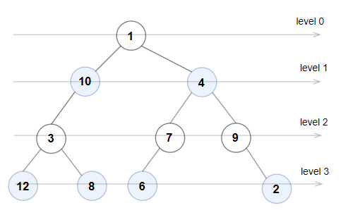

**Input:** root = [1,10,4,3,null,7,9,12,8,6,null,null,2]

**Output:** true

**Explanation:** The node values on each level are:

Level 0: [1]

Level 1: [10,4]

Level 2: [3,7,9]

Level 3: [12,8,6,2]

Since levels 0 and 2 are all odd and increasing, and levels 1 and 3 are all even and decreasing, the tree is Even-Odd.

**Example 2:**

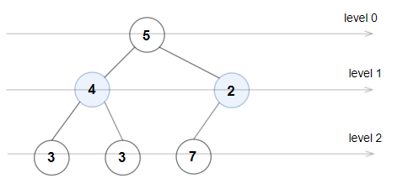

**Input:** root = [5,4,2,3,3,7]

**Output:** false

**Explanation:** The node values on each level are:

Level 0: [5]

Level 1: [4,2]

Level 2: [3,3,7]

Node values in the level 2 must be in strictly increasing order, so the tree is not Even-Odd.

**Example 3:**

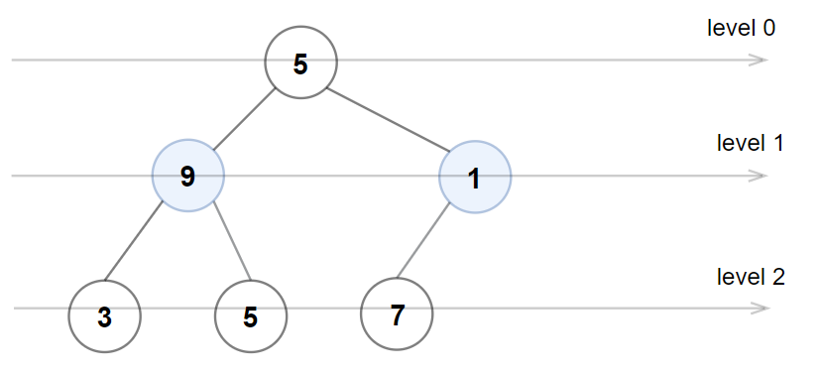

**Input:** root = [5,9,1,3,5,7]

**Output:** false

**Explanation:** Node values in the level 1 should be even integers.

**Example 4:**

**Input:** root = [1]

**Output:** true

**Example 5:**

**Input:** root = [11,8,6,1,3,9,11,30,20,18,16,12,10,4,2,17]

**Output:** true

**Constraints:**

* The number of nodes in the tree is in the range [1, 105].
* 1 <= Node.val <= 106

Accepted

15,816

Submissions

29,990